# Study Dashboards

## Steps to Create Study dashboards

**Rules:** 1. The Dashboards and Reports can be created using the uploaded study data through Data migration.

2.User can upload the data through Data Migration module only for Closed and not Public studies.

3.Once the Study is moved to public, actual study data cannot be uploaded. (Systems allows uploading of various documents, Reports and Public file through DMS but not the actual Study Data).

4. Data from multiple Tables can be used for the dashboard and Reporting purpose, but both the tables should have at least few common attributes.

**Steps**

**Step1: Click on “Access Study” at Repository Studies table, to view the study details.**

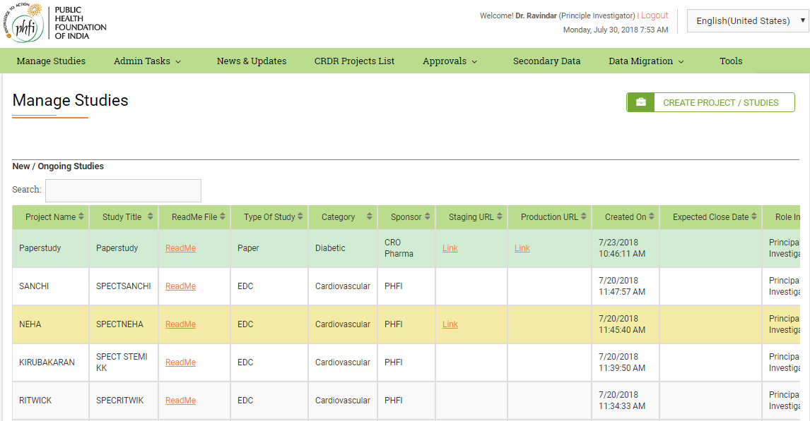

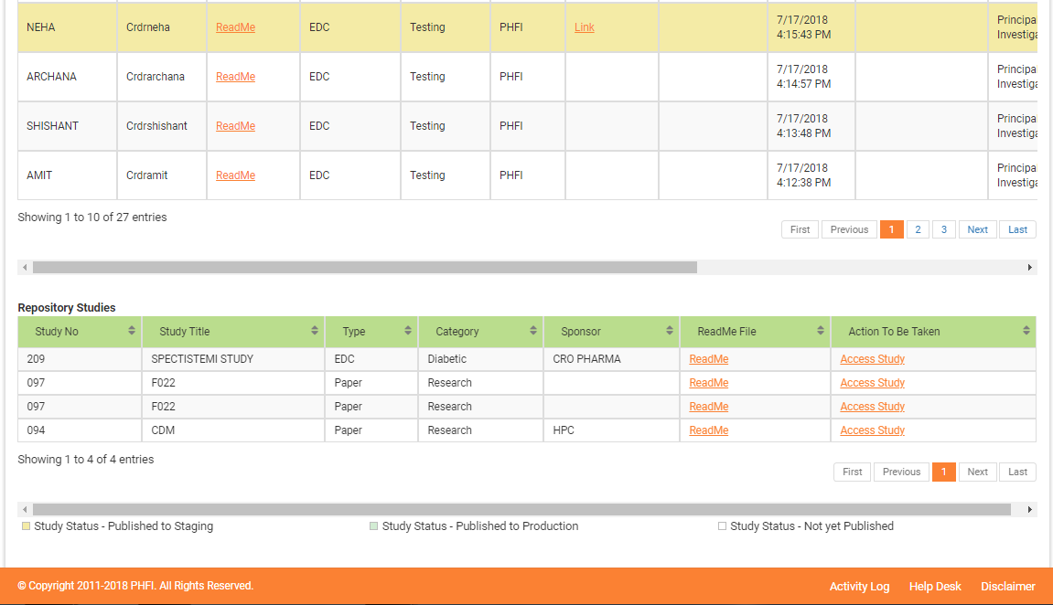

**Step 2:** On clicking “Access Study” system will navigate user to Study Details page, where

“Study Dashboards” option is available on the menu bar. Click on Study Dashboards module.

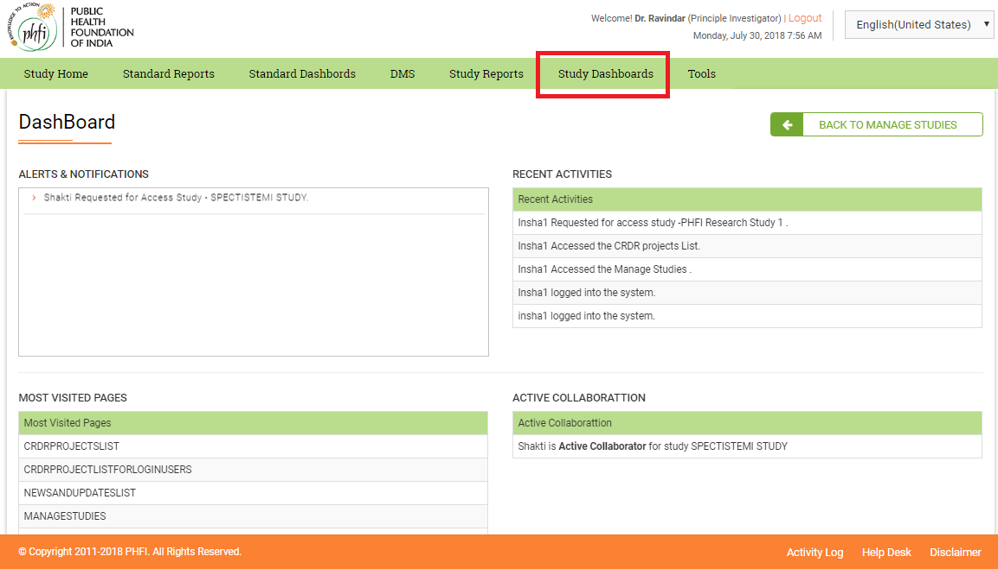

**Step 3:** Click on Study Dashboards

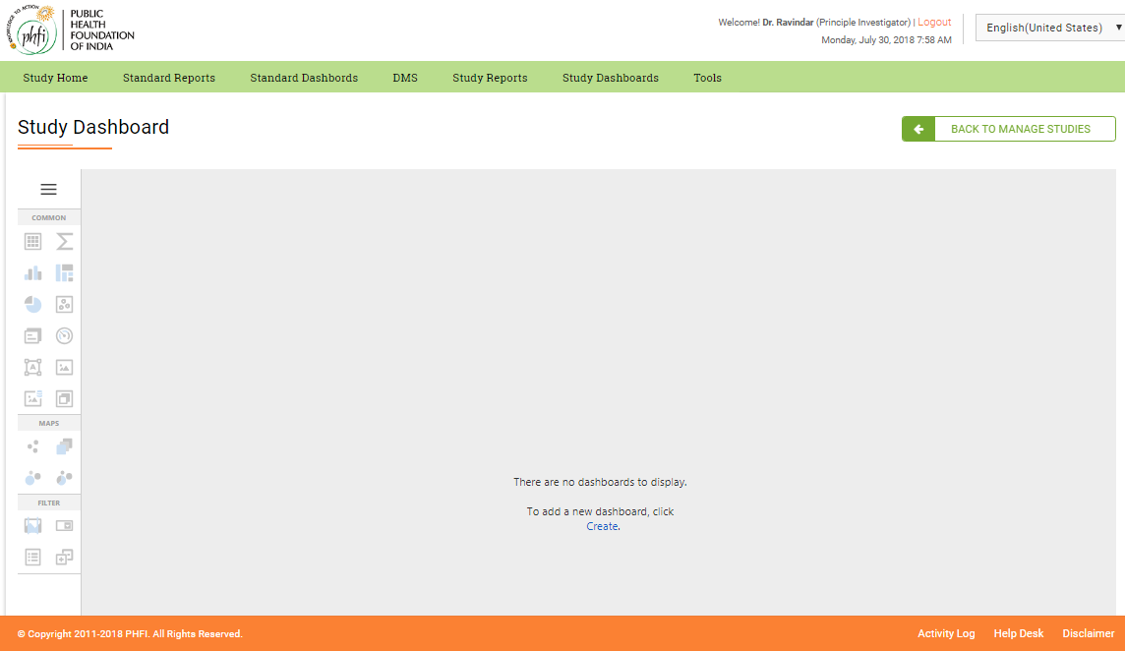

**Step 4:Click on Create link displayed on screen.**

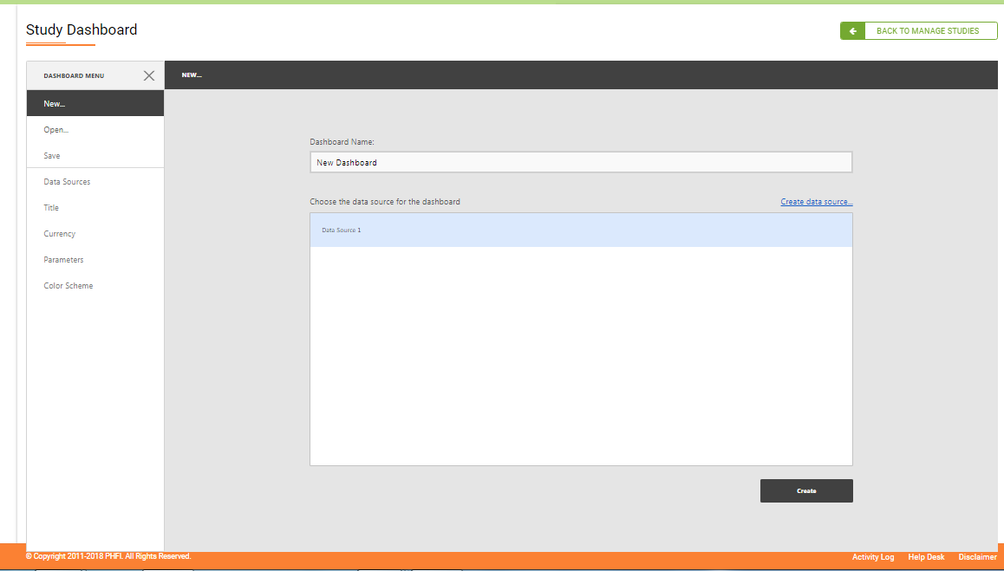

**Step 5: Provide the Naming details for the Dashboard ( here Dashboard Training). Click on create to start with dashboards.**

**Note: Ignore Create data source link(as this is taken care through development process.)**

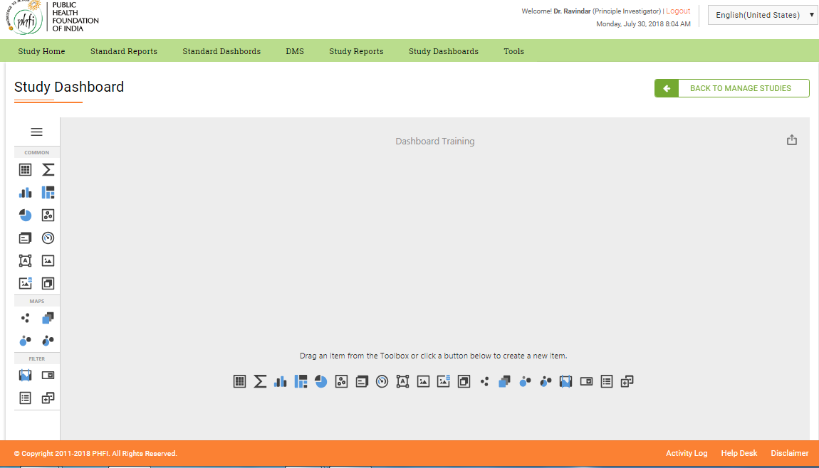

**Step 6: Dashboard Training empty dashboard is created. Now add the required dashboard item.**

**All the available dashboards are present in left menu and at middle of the page. Can proceed choosing any one dashboard item.**

**Note: Both menu items at center of page and left menu are same. Selection of either gives same result.**

**Step7 : creation of Grid Table**

* 1. **Click on grid dashboard from center or drag and drop from left menus.**

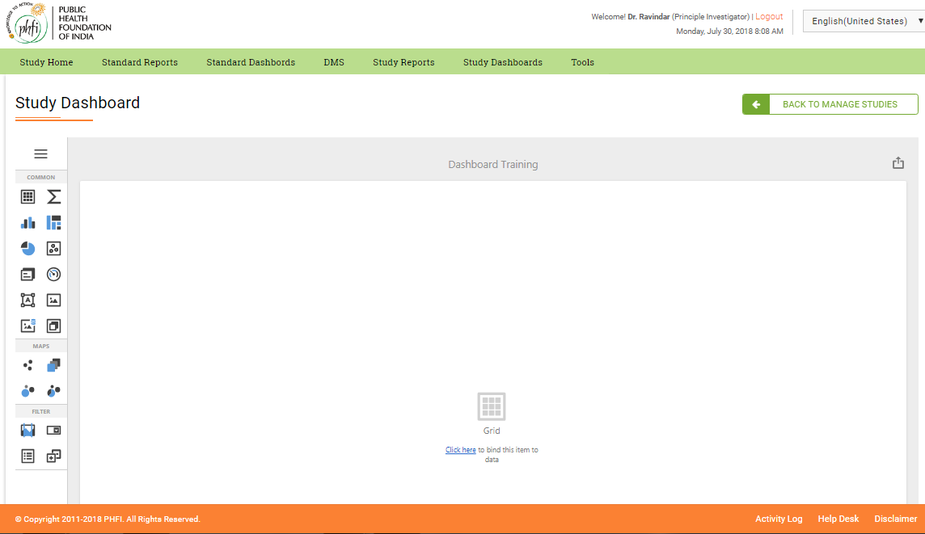

**7. 2 : Click on “Click here” to bind the item to data.**

**7.3 : Database selection menu appears on screen.**

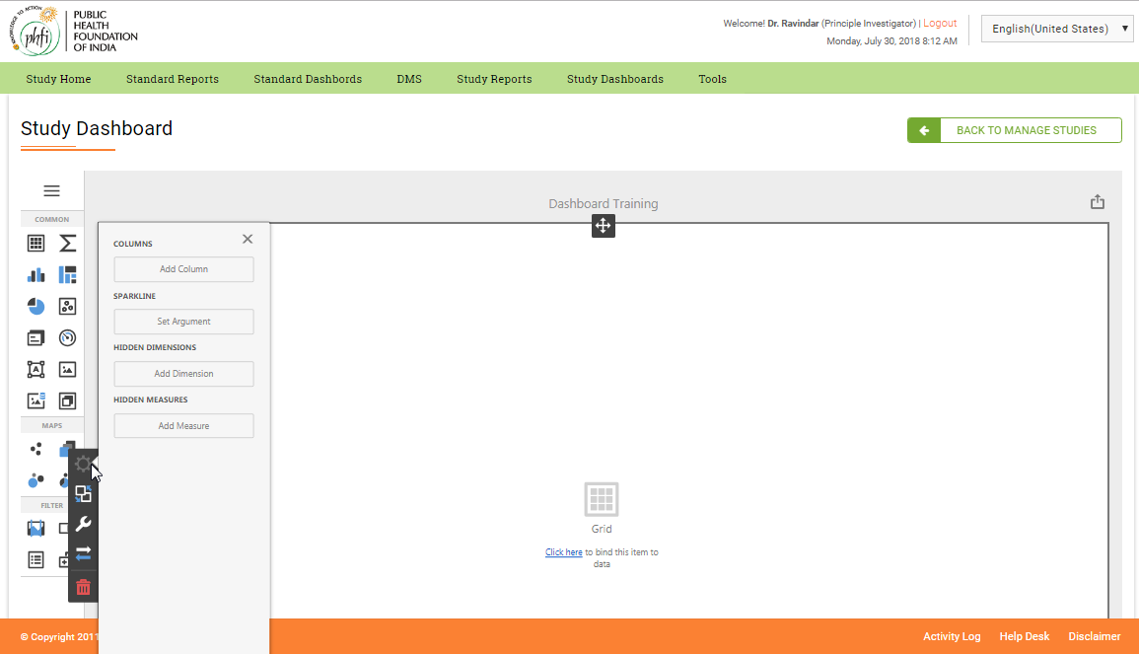

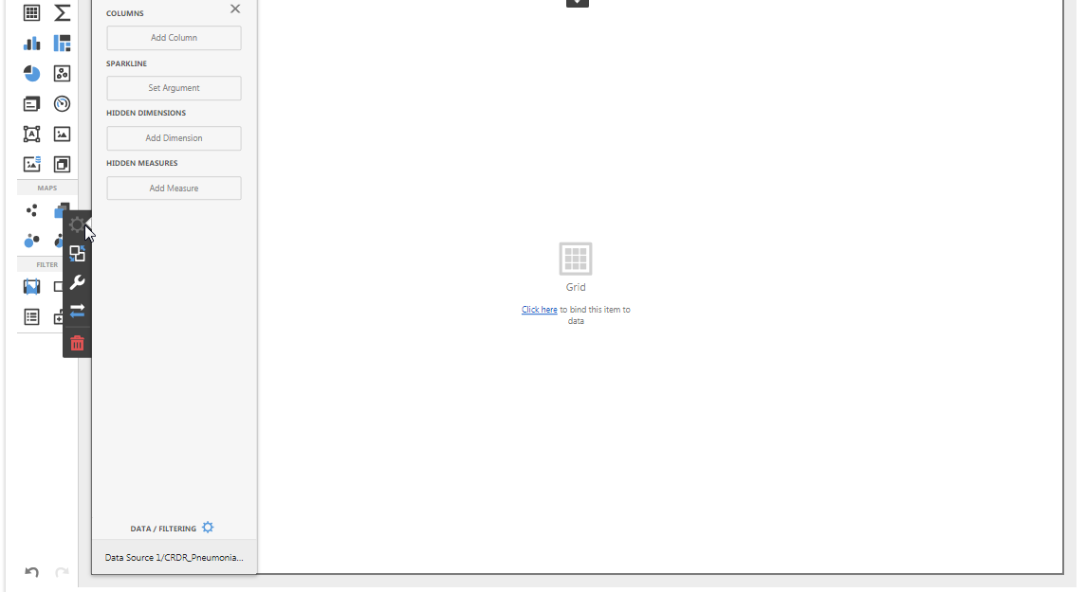

**7.4 Click on data source/(table name) at the data filtering available at bottom of menu.**

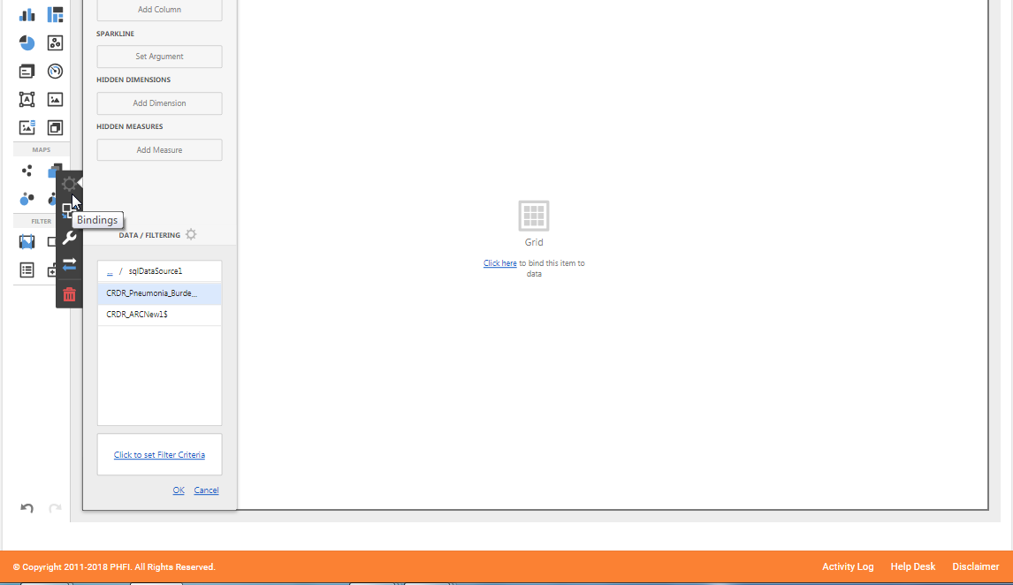

**7.5 Select the required table data from all the study data tables uploaded. Required table can be selected by clicking on the table listed and by clicking “ok”.**

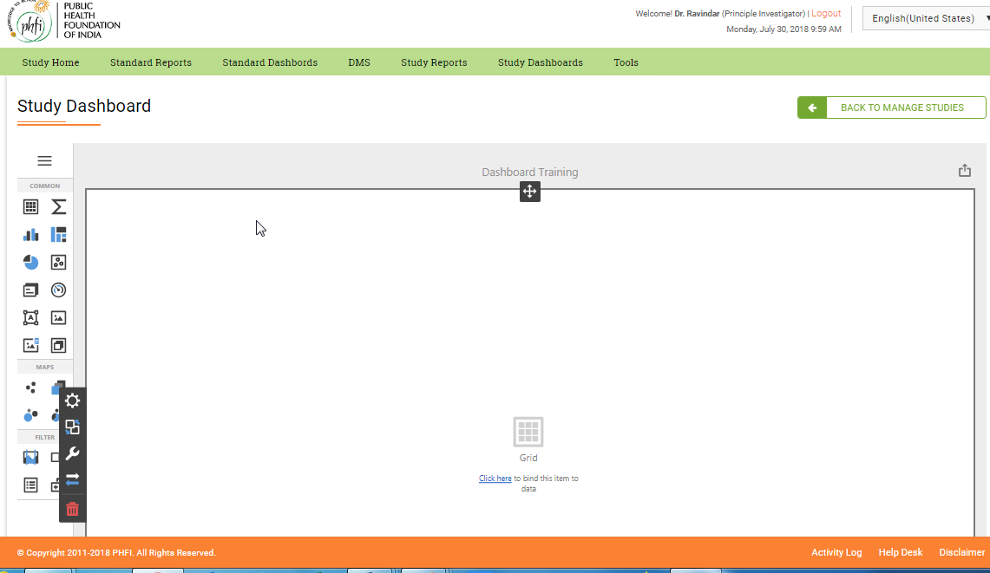

**7.6 On clicking on the grid system will display a options bar on the left.**